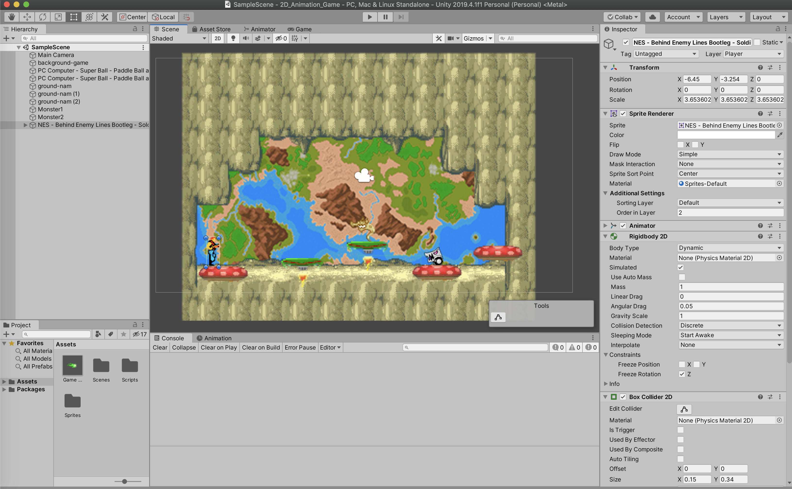

You can control your characters by “A”, “D” , W (to jump) and J to fire monsters.